1.(i) Write a R program to extract the five of the levels of factor created  
from a random sample from the LETTERS (Part of the base R distribution.)  
  (ii)Write R function to find the range ofgiven vector. Range=Max-Min  
Sample input, C<-(9,8,7,6,5,4,3,2,1),  
output=8

(iii)Wirte the R function to find the number  
of vowels in given string.

Sample input c<- “matrix”,  output<-2

ANS: 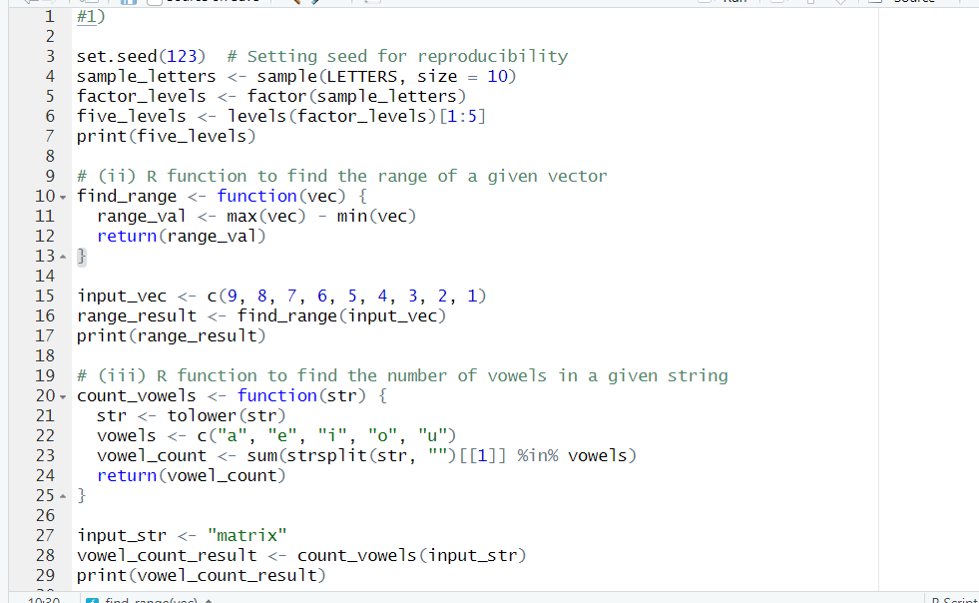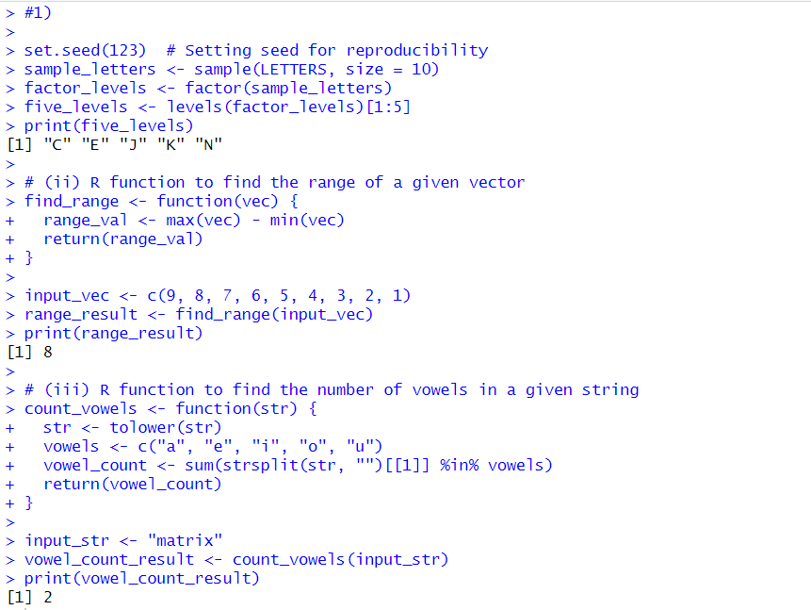   
  
2.Load inbuild dataset “ChickWeight” in R  
 (i) Explore the summary of Data set, like number of Features and its type. Fins the number of records for each features  
(ii)Extract last 6 records of dataset  
 (iii) order the data frame, in ascending order by feature name  “weight”  grouped by feature “diet”  
(iv)Perform melting function based on “Chick","Time","Diet"   features as ID  
variables  
(v)Perform cast function to display the mean  
value of weight grouped by Diet

ANS:  
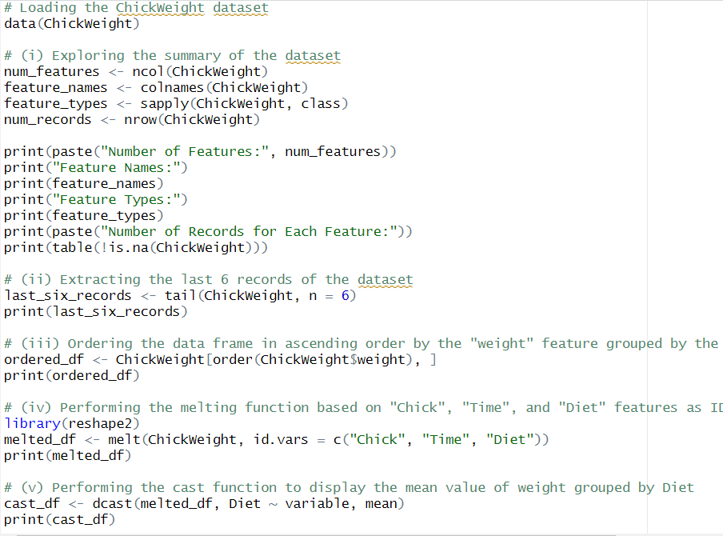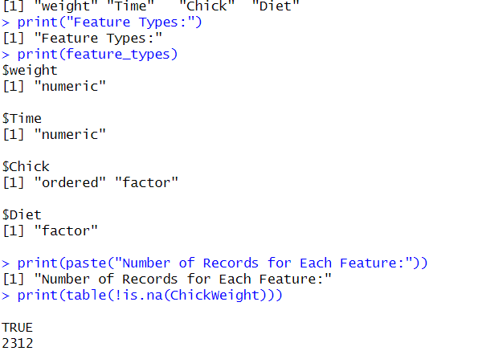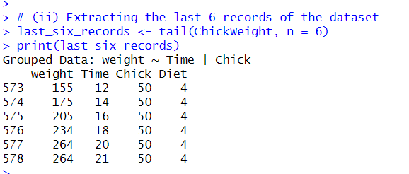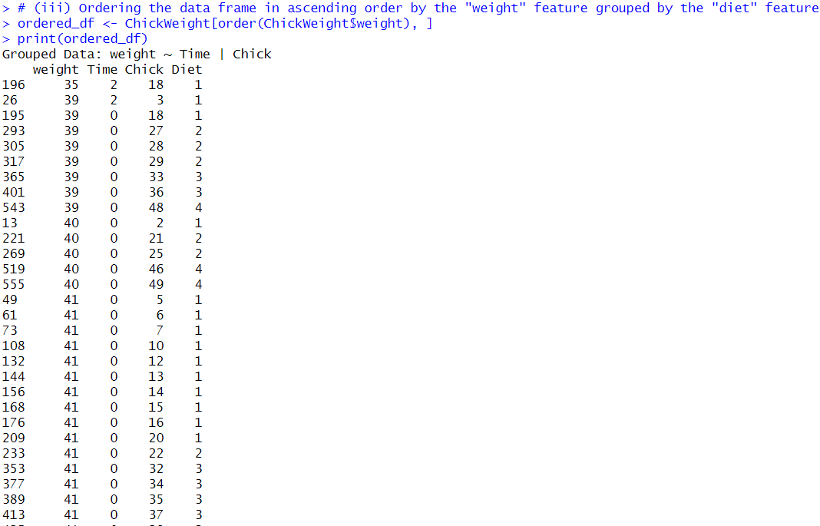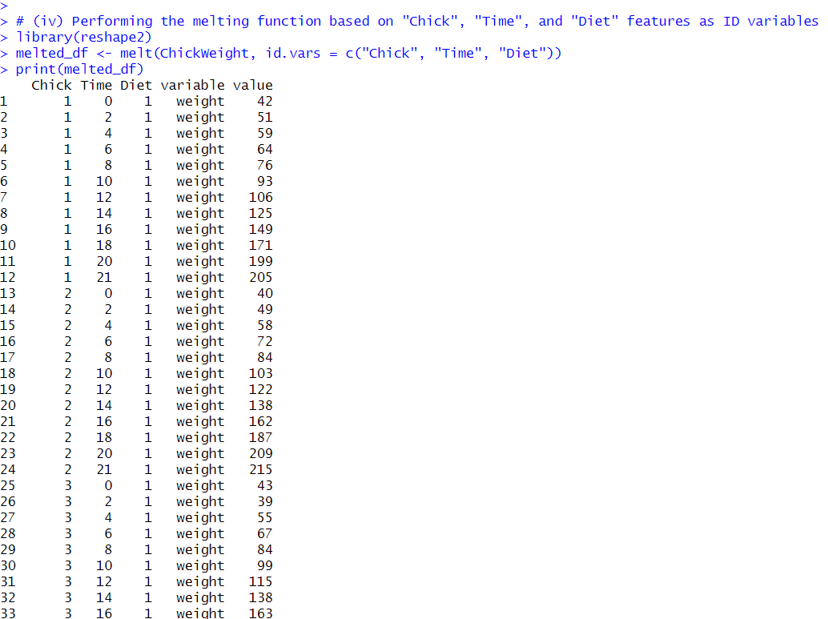

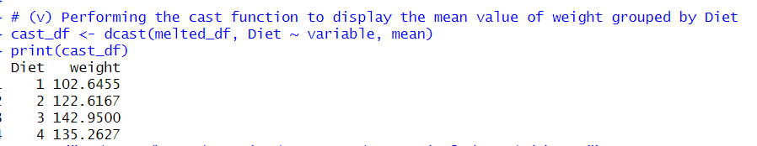

3.(i)Get the Statistical Summary of “ChickWeight” dataset

(ii)Create Box plot for “weight” grouped by “Diet”

(iii)Create a Histogram for “Weight” features belong to Diet- 1 category

(iv) Create a Histogram for “Weight” features belong to Diet- 4 category

(v) Create Scatter plot for weight vs Time grouped by Diet

ANS: 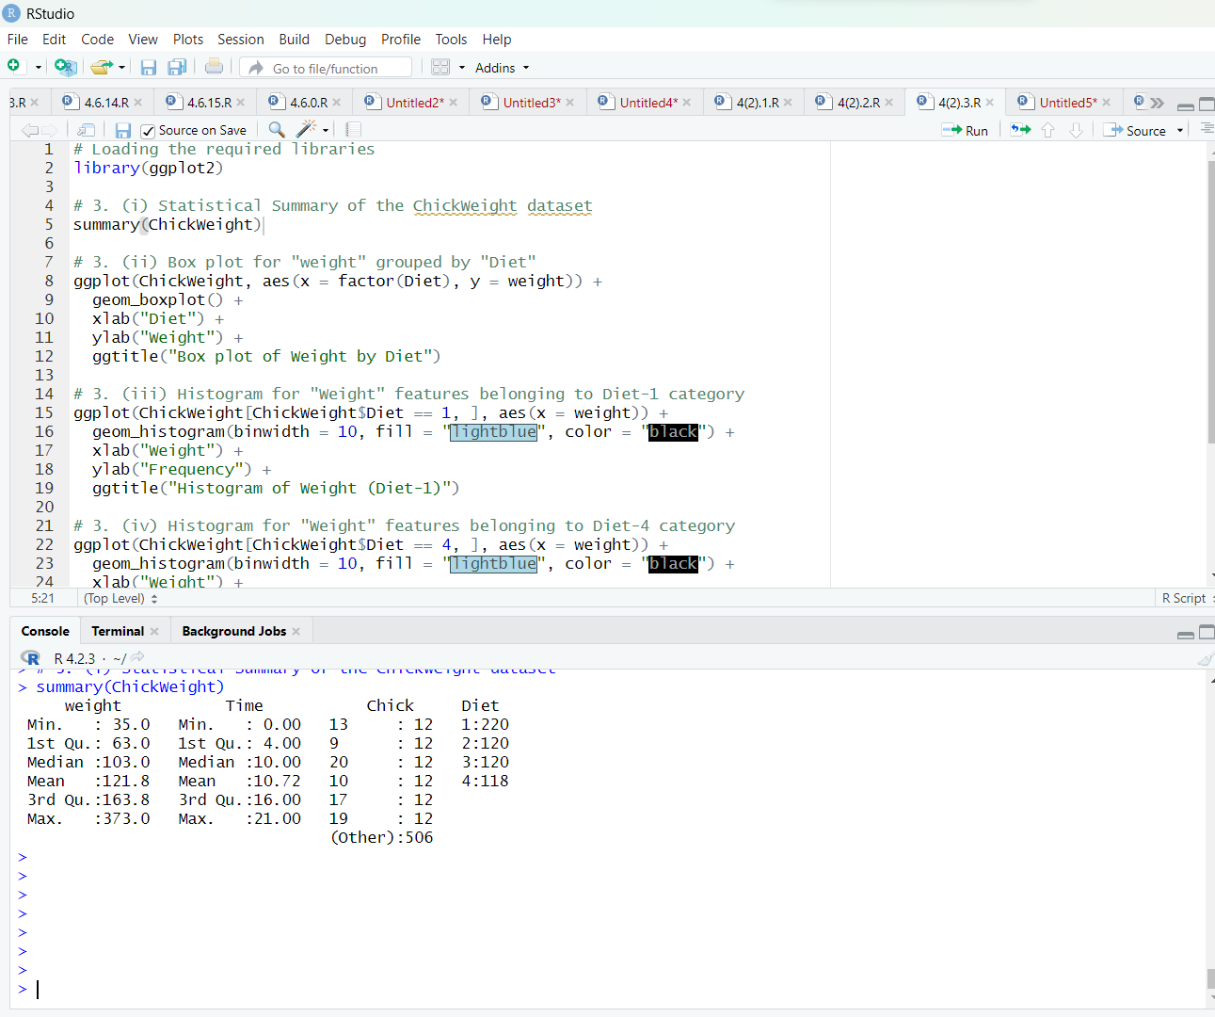

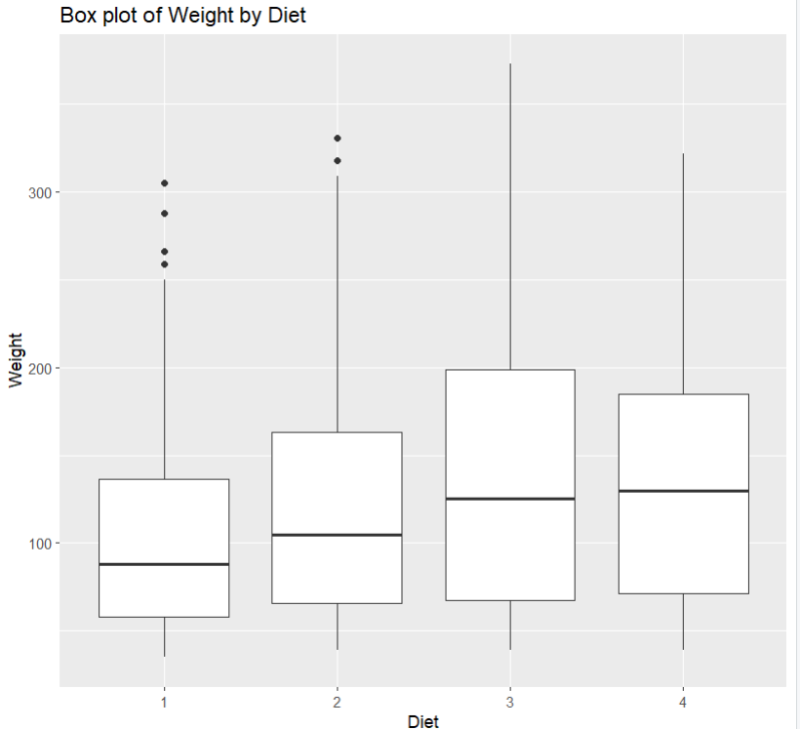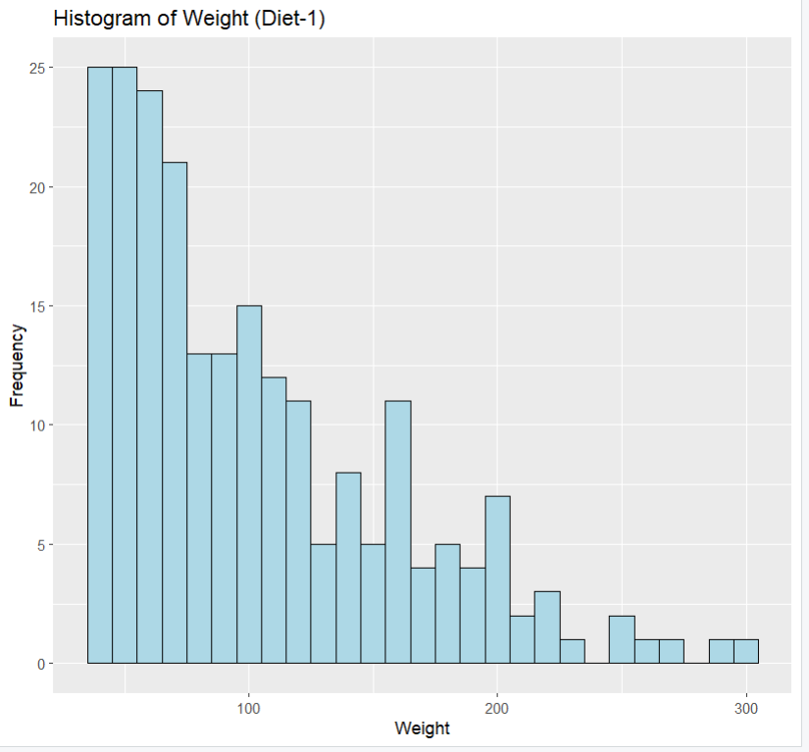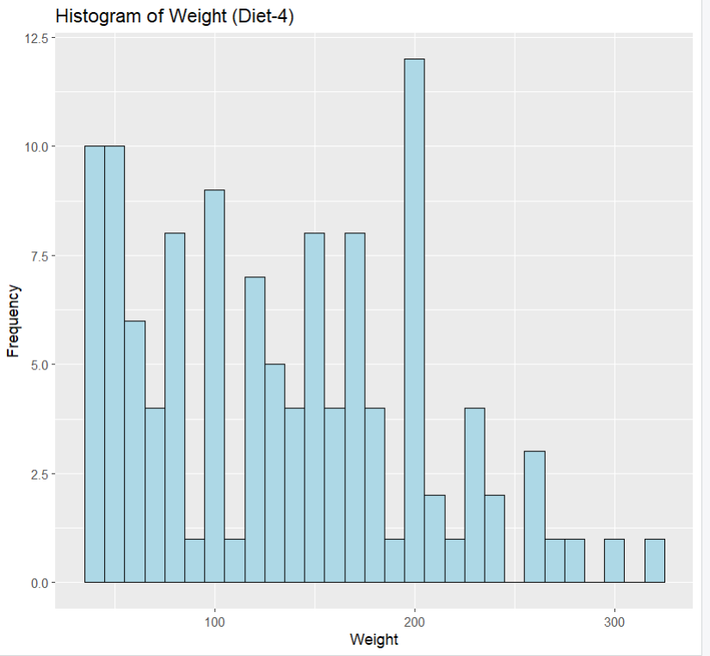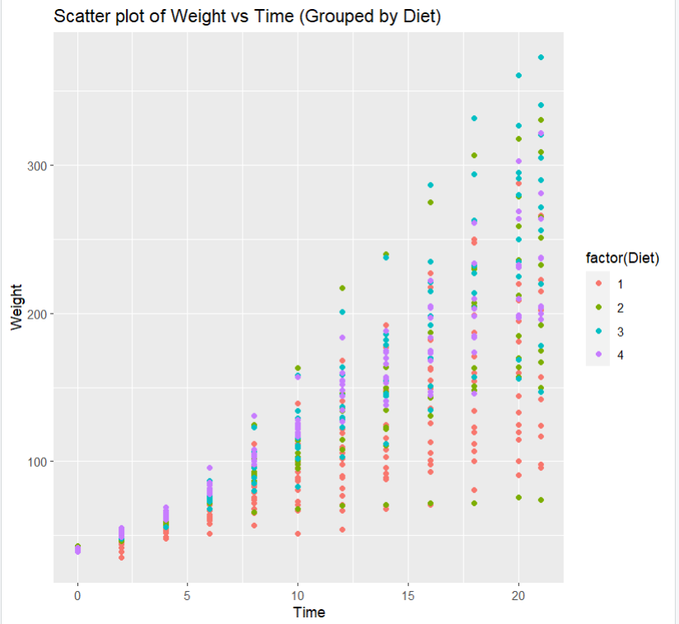

4) 4.(i) Create multi regression model to find a weight of the chicken , by “Time” and “Diet” as as predictor variables .

(ii) Predict weight for Time=10 and Diet=1.

(iii)Find the error in model for same

ANS:

